 [Translated from Chinese (Simplified) to English - www.onlinedoctranslator.com](https://www.onlinedoctranslator.com/en/?utm_source=onlinedoctranslator&utm_medium=docx&utm_campaign=attribution)

# MINI DS556-B2 Spontaneous Pulse Mode Instructions

MINI DS556-B2 is a customized product based on MINI DS556. It supports spontaneous pulse mode. The following is an introduction:

## **1. Description of spontaneous pulse function**

When the PLS or DIR signal is valid (PLS+ or DIR+ is high level, PLS- or DIR- is low level), the driver generates pulses spontaneously, and the motor rotates in the specified direction. The running speed is determined by the DIP switches (SW5-SW8). For details, please refer to the appendix "MINI DS556-B2 Spontaneous Pulse Speed ​​Table".

When the PLS and DIR signals are invalid (PLS+, PLS- and DIR+, DIR- are all high or low), the motor stops running.

## **2. Control signal interface description**

|  |  |
| --- | --- |
| **name** | **Functional Description** |
| PLS+ | Connect to +5V or +24V, the forward start signal is the positive terminal. |
| PLS- | Connect to the negative end of the forward start signal control signal, low level is valid. |
| DIR+ | Connect to +5V or +24V, and reverse the start signal to the positive terminal. |
| DIR- | Connect to the negative end of the reverse start signal control signal, low level is valid. |
| ENA+ | Connect to +5V or 24V to conduct |
| ENA- | When effective (low level), the motor coil current is turned off and the motor is in a free state |

## **3. Motor rotation direction control**

|  |  |  |
| --- | --- | --- |
| **DIR signal** | **PLS signal** | **Direction of rotation** |
| invalid | invalid | stop |
| invalid | efficient | Positive direction |
| efficient | invalid | Reverse direction |
| efficient | efficient | Reverse direction |

**Notice:**The rotation direction shown in the above table is for reference only. The actual rotation direction is also related to the wiring of the motor.

## **4. Built-in acceleration and deceleration functions**

All speed gears have built-in acceleration and deceleration functions, and the acceleration and deceleration time is about 100ms.

## **5. With 16 speed options**

The minimum speed is 5r/min, the maximum speed is 80r/min, and it increases by 5r/min. For details, please refer to the appendix "MINI DS556-B2 Spontaneous Pulse Speed ​​Table".

# appendix:

## **(1) MINI DS556-B2 interface diagram**

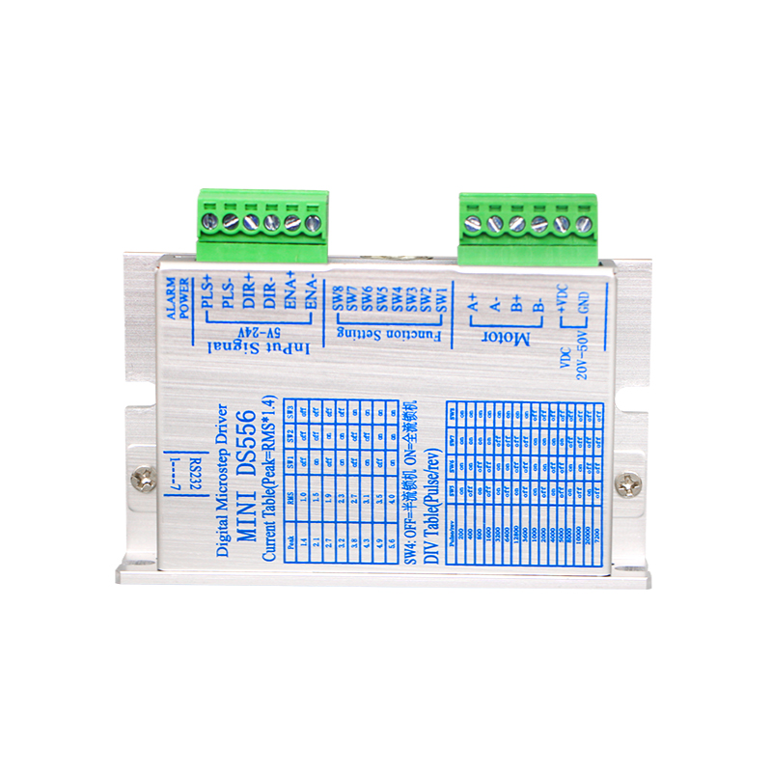

## **(2) MINI DS556-B2 speedometer**

|  |  |  |  |  |  |
| --- | --- | --- | --- | --- | --- |
| **Speed(r/min)** | **Speed(r/s)** | **SW5** | **SW6** | **SW7** | **SW8** |
| 80 | 1.333 | on | on | on | on |
| 75 | 1.250 | off | on | on | on |
| 70 | 1.167 | on | off | on | on |
| 65 | 1.083 | off | off | on | on |
| 60 | 1.000 | on | on | off | on |
| 55 | 0.917 | off | on | off | on |
| 50 | 0.833 | on | off | off | on |
| 45 | 0.750 | off | off | off | on |
| 40 | 0.667 | on | on | on | off |
| 35 | 0.583 | off | on | on | off |
| 30 | 0.500 | on | off | on | off |
| 25 | 0.417 | off | off | on | off |
| 20 | 0.333 | on | on | off | off |
| 15 | 0.250 | off | on | off | off |
| 10 | 0.167 | on | off | off | off |
| 5 | 0.083 | off | off | off | off |

## **(3) Current setting**

|  |  |  |  |  |
| --- | --- | --- | --- | --- |
| **Output peak current** | **Output effective current** | **SW1** | **SW2** | **SW3** |
| 1.4 | 1.0 | off | off | off |
| 2.1 | 1.6 | on | off | off |
| 2.7 | 1.9 | off | on | off |
| 3.2 | 2.3 | on | on | off |
| 3.8 | 2.7 | off | off | on |
| 4.3 | 3.1 | on | off | on |
| 4.9 | 3.5 | off | on | on |
| 5.6 | 4.0 | on | on | on |

## **(4) Static (quiescent) current setting**

The quiescent current can be set using the SW4 dip switch. Off means that the quiescent current is set to half of the dynamic current, and on means that the quiescent current is the same as the dynamic current.